Double Specialty Show Week-End

2017404201 and 2017404203 Conformation; All-Breed Obedience; Jr. Showmanship
2017404202 and 2017404204 Rally
2017404207 and 2017404208 4-6 Month Beginner Puppy Class

SPECIALTY SHOW & ALL-BREED OBEDIENCE TRIAL & RALLY TRIAL
Licensed by the American Kennel Club

**Limited Conformation Entries: 100 Entries per Show
**Limited Obedience Entries: 75 Entries per Show
**Limited Rally Entries: 60 Entries per Show

ENTRIES CLOSE AT 6:00 PM FRIDAY, September 8, 2017
(after which time entries cannot be accepted, cancelled, or substituted except as provided for in Chapter 11, Section 6 of the Rules Applying to Dog Shows)

Obedience & Rally entries are open to
All-American Dogs listed in the AKC Canine Partners Program

AUGUSTA GERMAN SHEPHERD DOG CLUB, INC

PREMIUM LIST
(UNBENCHED)
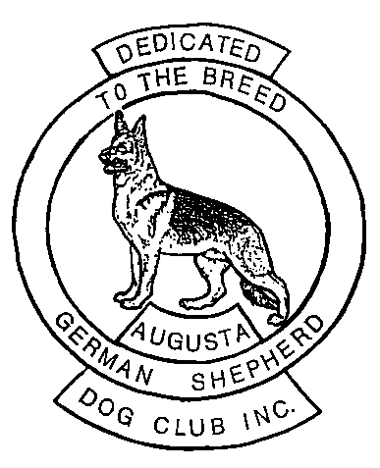
SATURDAY, SEPTEMBER 23, 2017
SUNDAY, SEPTEMBER 24, 2017
Show Hours 8am to 6pm E.D.T.
Judging will be outdoors regardless of weather.
Riverside Park, 4431 Hardy McManus Rd, Evans, GA 30809
AUGUSTA GERMAN SHEPHERD DOG CLUB, INC.

OFFICERS
PRESIDENT Gene Workman
VICE PRESIDENT Sherry McFarland
TREASURER Dianne Boykin
SECRETARY Angie Hubbard
3802 Old Waynesboro Rd, Augusta, GA 30906
BOARD OF DIRECTORS
Lynda Bragg-Workman Jerry Lyda Leslie Hutto

*** BENCH SHOW and OBEDIENCE TRIAL COMMITTEE ***

All Club Officers and Directors are members of the Bench Show and Obedience Trial Committee

CHAIRPERSON SHOW SECRETRARY

Sherry McFarland Dianne Boykin
Phone: Cell # (706) 284-6516 3592 Marlboro Way
Hm #(706) 541-0582 Martinez, GA 306907
Hm # (706) 860-8891
Lynda Bragg-Workman Cell # (706) 284-6455
Phone: Cell # (706) 825-6834 e-mail: drboykin@bellsouth.net
Hm # (706) 793-2584

EVENT COMMITTEE

Gene Workman Lynda Bragg-Workman
Jon Hutto Sherry McFarland
Angie Hubbard

CATALOG HOSPITALITY
Leslie Hutto Gene Workman

PHOTOGRAPHER – TBD

VETERINARIAN

Augusta Animal Emergency
208 Hudson Trl, Augusta, GA 30907
(706) 733-7458

AMERICAN KENNEL CLUB CERTIFICATION
Permission has been granted by the American Kennel Club for the holding of these events under American Kennel Club Rules and Regulations.
James P. Crowley, AKC Secretary
-2-

NOTICE TO EXHIBITORS

This show is Unbenched. Show hours are 8:00 AM to 6:00 PM. No admission is charged. Dogs which,
according to their owner’s records, have completed the requirements for a championship after the closing for this show, but whose championships are unconfirmed may be transferred from one of the regular classes to the Best of Breed competition, provided this transfer is made by the Show Secretary at least one-half hour prior to the start of judging at this show.
The Management and Show giving club disclaims any liability after the judging is over. Owners are responsible for errors on entry blanks.

CLOSING DATE FOR ENTRIES: 6:00 PM Eastern Time, Friday, September 8, 2017 (at show
Secretary’s Office) after which time entries cannot be accepted, canceled or substituted, except as provided for in Chapter ll, Section 6 of the Dog Show Rules.

TELEGRAPH, TELEPHONE, AND UNSIGNED ENTRIES CANNOT BE ACCEPTED.

DOGS MAY ARRIVE ANY TIME PRIOR to their scheduled time for judging. After being judged, DOGS NOT REQUIRED FOR FURTHER JUDGING may be excused. NO DOG MAY BE PERMANENTLY REMOVED from the Show before it is judged, except by consent of the SHOW SECRETARY upon a veterinarian’s recommendation of removal.

ENTRY FEE shall not be refunded in the event that a dog is absent, disqualified, excused by the Veterinarian or Judge or barred from competition by the Show Committee. Refunds will be made for bitches entered in Obedience upon written certification by a Veterinarian that the bitch is in season; certification must be received by the Show Secretary prior to the start of the judging.

“Exhibitors should follow their veterinarians’ recommendation to assure their dogs are free of internal and external parasites, and communicable diseases, and have appropriate vaccinations.”

MOTELS

Red Roof Inn & Suites – 4328 Frontage Road, Augusta, GA 30909
(706) 228-3031

LaQuinta Inn & Suites, 3020 Washington Road, Augusta, GA 30907
(706) 733-2660

-11-

AKC Rules, Regulations, Policies and Guidelines are available on the American Kennel Club Web site.
www.akc.org

AGREEMENT

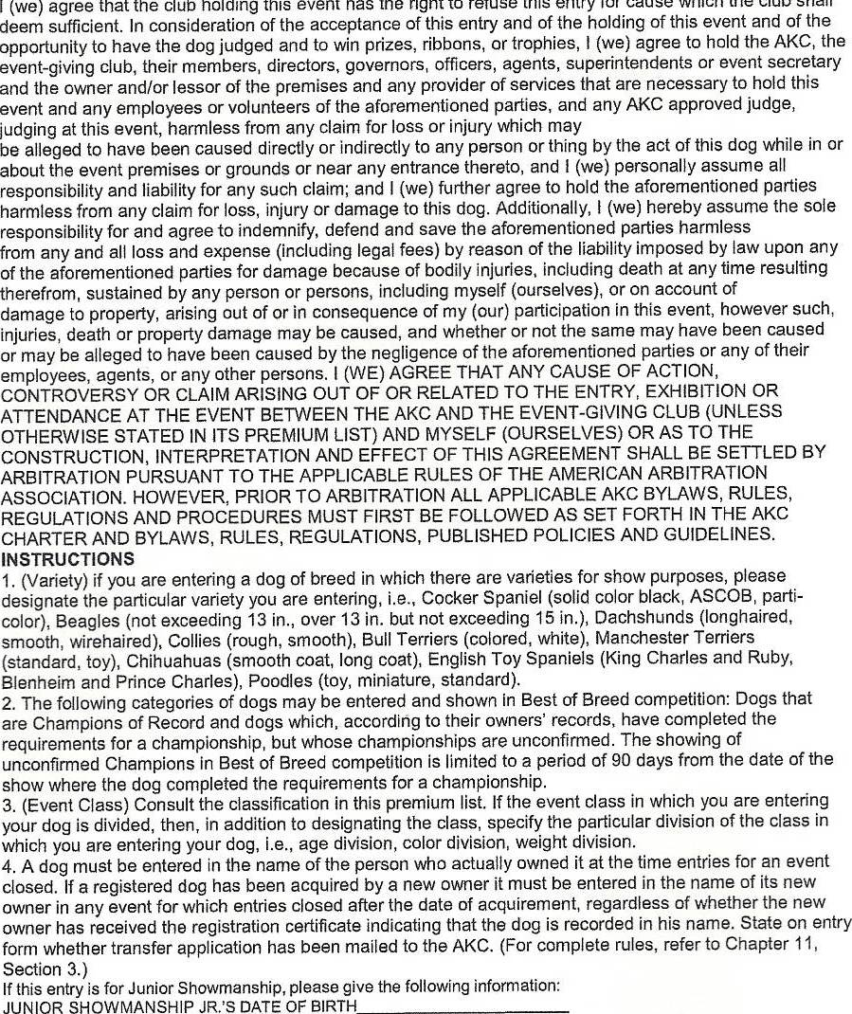

-10-

JUDGES
Saturday, Sept. 23, 2017…………………
4 – 6 Month Beginner Puppy… ……………………………Ms. Rita G. Sandell
3115 Gulf Shore Blvd. N 408 S., Naples, FL 34103

Breed; Jr. Showmanship…………………………………... Ms. Rita G. Sandell
3115 Gulf Shore Blvd. N 408 S., Naples, FL 34103

Obedience……..Novice A……..Novice B…………….........Ms. Connie Parrish
Beg. Novice A…………Beg. Novice B…………………….Ms. Connie Parrish
Pref. Novice.………………………………………...............Ms. Connie Parrish
Open A………………Open B……………………………. Ms. Connie Parrish
Pref. Open….…………Pref. Utility.… …………………….Ms. Connie Parrish
Utility A……………..Utility B……………………..............Ms. Connie Parrish
Veterans……………………………………………………..Ms. Connie Parrish
235 Gray Hwy., Gordon, GA 31031-3304

Rally….Novice A & B………Adv. A & B………………..Ms. Connie Parrish
Excellent A & B…………....................................................Ms. Connie Parrish
235 Gray Hwy., Gordon, GA 31031-3304

Sunday, Sept. 24, 2017…………………….
4 – 6 Month Beginner Puppy…………………………….. Mrs. Kathy O. Potter
1140 Bulltail Rd., Ivanhoe, NC 28447-8908

Breed; Jr. Showmanship…………………………………. Mrs. Kathy O. Potter
1140 Bulltail Rd., Ivanhoe, NC 28447-8908

Obedience……..Novice A……..Novice B……….................Ms. Connie Parrish
Beg. Novice A…………Beg. Novice B…………………….Ms. Connie Parrish
Pref. Novice………………………………………………....Ms. Connie Parrish
Open A………………Open B…………………………….. Ms. Connie Parrish
Pref. Open…………Pref. Utility…………………………....Ms. Connie Parrish
Utility A……………..Utility B……………………………..Ms. Connie Parrish
Veterans……………………………………………………..Ms. Connie Parrish
235 Gray Hwy., Gordon, GA 31031-3304

Rally….Novice A & B………Adv. A & B………………...Ms. Connie Parrish
Excellent A & B…………....................................................Ms. Connie Parrish 235 Gray Hwy., Gordon, GA 31031-3304

Saturday, September 23, 2017- Judging will begin promptly at 10:00 a.m. for
Conformation
………………………………9 :00 am for Obedience and
Rally will follow immediately after the completion of Obedience.
Sunday, September 24, 2017- Judging will begin promptly at 9:00 am for
Conformation
………………………………9:00 am for Obedience and
Rally will follow immediately after the completion of Obedience.

RIBBON PRIZES

Regular Classes
First Blue
Second .Red
Third Yellow
Fourth White
Winner Purple Rosette
Reserve Winners Purple and White Rosette
Best of Winners Blue and White Rosette
Best of Breed Purple and Gold Rosette
Best of Opposite Sex Red and White Rosette
Best Puppy Dark Green Rosette
Best Opposite Puppy……………………………Dark Green Rosette & White
High Score in Trial Blue and Gold Rosette
High Score GSD in Trial Dark Green Rosette & White
High Combined .Blue and Gold Rosette
High Combined GSD in Trial Dark Green & White Rosette
Qualifying Score Dark Green
Non-Regular Classes
First Rose
Second Brown
Third Lt. Green
Fourth Grey
Best Veteran ………………………………Green With Pink Edges Rosette

Junior Show Ribbon Prizes Include Best Jr. – Rose & Green Rosette

4 – 6 Beginner Puppy Class – Best 4-6 Month Puppy – Orange Rosette
Best Opposite 4-6 Month Puppy – Lavender Rosette

New Title Rosette will be available

Select Rosette – Lt. Blue & White Rosette

-4-

OFFICIAL AMERICAN KENNEL CLUB ENTRY FORM
Specialty Show Specialty Show 2017404201 and 2017404203 Conformation;
All-Breed Obedience; Jr. Showmanship
2017404202 and 2017404204 Rally
2017404207 and 2017404208 4-6 Month Beginner Puppy Class

AUGUSTA GERMAN SHEPHERD DOG CLUB, INC.

CHECK APPROPRIATE BOX(ES) ⁮ Saturday, September 23, 2017
⁮ Sunday, September 24, 2017

ENTRY FEES: $28.00 for first entry of a dog in a regular Conformation or Obedience class. $22.00 for 2nd entry of same dog in Conformation/Obedience class. $28.00 for 1st entry of a dog in Rally class. $22.00 for 2nd entry of same dog in Rally class. $22.00 for Puppy (6-9 /
9-12 month), Bred by Exhibitor & AOTH classes. $10.00 for 4-6 mo. Puppy and Veterans Conformation and Veterans Obedience classes. Junior Showmanship is Free. A $2.00 recording fee will be paid to the American Kennel Club from each entry and a $3.00 recording fee will be paid to AKC for Rally.
CLOSING DATE: 6:00 PM Eastern time, Friday, September 8, 2017, at Shows Secretary’s office after which time entries CANNOT be accepted, canceled or substituted, except as provided for in Chapter 14, Section 6 of the Dog Show Rules.
MAKE ALL CHECKS AND MONEY ORDERS PAYABLE TO AUGUSTA GERMAN SHEPHERD DOG CLUB, INC.
MAIL ALL ENTRIES WITH FEES TO: Dianne Boykin, 3592 Marlboro Way, Martinez, GA 30907
-9-

AKC Rules, Regulations, Policies and Guidelines are available on the American Kennel Club Web site.
www.akc.org

AGREEMENT

-8-

ENTRY FEES: $28.00 for first entry of a dog in a regular Conformation or Obedience class. $22.00 for 2nd entry of same dog in Conformation/Obedience class. $28.00 for 1st entry of a dog in Rally class. $22.00 for 2nd entry of same dog in Rally class. $22.00 for Puppy ( 6-9 /
9-12 month), Bred by Exhibitor & AOTH classes. $10.00 for 4-6 mo. Puppy and Veterans Conformation and Veterans Obedience classes. Junior Showmanship is Free. A $2.00 recording fee will be paid to the American Kennel Club from each entry and a $3.00 recording fee will be paid to AKC for Rally.

BREED SHOW CLASSIFICATION
PUPPY DOGS………… (4 months and under 6 months)………...PUPPY BITCHES
PUPPY DOGS………… (6 months and under 9 months)………...PUPPY BITCHES
PUPPY DOGS………….(9 months and under 12 months)………PUPPY BITCHES
DOGS…………………..(12 months and under 18 months)……………….BITCHES
NOVICE DOGS………………………………… ………………NOVICE BITCHES
AOTH DOGS....................................................................................AOTH BITCHES
BRED-BY-EXHIBITOR DOGS……………......BRED-BY-EXHIBITOR BITCHES
AMERICAN BRED DOGS……………………….....AMERICAN BRED BITCHES
OPEN DOGS………………………………………………………..OPEN BITCHES
WINNERS………BOB…....…BOS…..……BEST PUPPY……BEST OPP. PUPPY

NON –REGULAR CLASSES
VETERAN DOGS………..(Over 7 years of age)……………VETERAN BITCHES
Neutered Dogs & Spayed Bitches May be Entered in Veterans Classes

OBEDIENCE
UTILITY A………………………..…………………………………….UTILITY B
OPEN A…………………………………………………………………..…OPEN B
PREF. OPEN……………………………………………….PREF. UTILITY OPEN
NOVICE A……………………………………………………………….NOVICE B
PREF. NOVICE……………………………………………………………………..
BEGINNING NOVICE A .………………………………BEGINNING NOVICE B
VETERANS…………………………………………………………………………

RALLY TRIAL CLASSES: Novice A, Novice B, Advanced A, Advanced B, Excellent A; Excellent B

Obedience & Rally entries must include dog’s jump height. Move ups will be allowed prior to start of trial per AKC Regulations. Qualifying Scores Required for All Prizes in Regular Classes.

JUNIOR SHOWMANSHIP CLASSES ARE FREE
All Junior Handlers will receive a keepsake.
-
Classes offered: Novice Jr., Novice Interm.; Novice Sr., Open Jr.; Open Intem.; Open Sr., Best Junior Handler

CLUB MEMBERS WILL CONDUCT A DOG SHOW TOUR FOR INTERESTED PERSONS. SIGN IN AT CATALOG TABLE.

-5-

BREED PRIZES

The Augusta GSD Club will offer trophies for the following at each show:

Conformation:

Best of Breed Best of Opposite
Winners Reserve Winners
Best Puppy Best Opposite Puppy
Best Veteran Best Junior Handler

Each Junior handler shall receive a participation gift from the club.

Bronze medallions will be offered for Best of Breed each day.

*Obedience:

High In Trial High GSD In Trial
High Combined High Combined GSD
Oldest GSD Obedience Qualifyer**

**THIS AWARD MUST BE SIGNED UP AT TROPHY TABLE
BEFORE JUDGING ENDS.

1st in each obedience class GSD

1st in each class – all breeds

High Scoring in Regular classes on SATURDAY only:
Austrian Shepherd
Golden Retriever Yorkshire Terrier
Labrador Retriever All American Dog

Bronze medallions will be offered for High Combined GSD each day

*Rally:

High Combined Rally High Combined GSD Rally
High In Trial GSD Rally

1st in each Rally class GSD
1st in each Rally class – all breeds

*Qualifying Score required for all trophies offered in Obedience/Rally

-6-

OFFICIAL AMERICAN KENNEL CLUB ENTRY FORM
Specialty Show Specialty Show 2017404201 and 2017404203 Conformation;
All-Breed Obedience; Jr. Showmanship
2017404202 and 2017404204 Rally
2017404207 and 2017404208 4-6 Month Beginner Puppy Class

AUGUSTA GERMAN SHEPHERD DOG CLUB, INC.

CHECK APPROPRIATE BOX(ES) ⁮ Saturday, September 23, 2017
⁮ Sunday, September 24, 2017
ENTRY FEES: $28.00 for first entry of a dog in a regular Conformation or Obedience class. $22.00 for 2nd entry of same dog in Conformation/Obedience class. $28.00 for 1st entry of a dog in Rally class. $22.00 for 2nd entry of same dog in Rally class. $22.00 for Puppy (6-9 / 9-12 month), Bred by Exhibitor & AOTH classes. $10.00 for 4-6 mo. Puppy and Veterans Conformation and Veterans Obedience classes. Junior Showmanship is Free. A $2.00 recording fee will be paid to the American Kennel Club from each entry and a $3.00 recording fee will be paid to AKC for Rally.
CLOSING DATE: 6:00 PM Eastern time, Friday, September 8, 2017, at Shows Secretary’s office after which time entries CANNOT be accepted, canceled or substituted, except as provided for in Chapter 14, Section 6 of the Dog Show Rules.
MAKE ALL CHECKS AND MONEY ORDERS PAYABLE TO AUGUSTA GERMAN SHEPHERD DOG CLUB, INC.
MAIL ALL ENTRIES WITH FEES TO: Dianne Boykin, 3592 Marlboro Way, Martinez, GA 30907
-7-

